

|  |  |
| --- | --- |
| **Course Title** | Scalable Services |
| **Course No(s)** | SEMTZG583 |
| **Student Name** | Vikas Banukunta |
| **Student Id** | 2021mt70057 |

ASSIGNMENT QUESTION (IMPLEMENTATION)

Build a scalable e-commerce platform using microservices architecture. The platform will consist of several services, including product catalog, user management, order processing, and payment processing. Leverage open-source technologies and running them on your local machine or a local development environment to implement a scalable microservices architecture without incurring any costs for infrastructure.

Technologies to be used: (All opensource)

* Programming Languages: Node.js, Python - Set up a local development environment on your machine. Install necessary tools such as Node.js, Python, Docker, and Kubernetes locally.
* Frameworks: Express.js, Flask – Leverage opensource framework
* Container Orchestration: Docker, Kubernetes: Use Minikube, you to run Kubernetes locally on your machine. Using Minikube set up a single-node Kubernetes cluster on your local environment to deploy and test your microservices.
* Database: MongoDB, PostgreSQL – Install and Run MongoDB and PostgreSQL instances locally for development and testing purposes
* Message Broker: RabbitMQ – Install RabbitMQ on your local machine for message broker capabilities.
* API Gateway: Kong - Install Kong API Gateway on your local to provide API Gateway functionality
* Monitoring: Prometheus, Grafana- Set up Prometheus and Grafana locally for monitoring and logging. Both tools are open-source and can be configured to collect and visualize metrics from your microservices running on Kubernetes.

Perform Steps as given below:

1. Define Microservices: Identify the services needed for the e-commerce platform, such as product service, user service, order service, payment service, etc. Each service should have a well-defined scope and responsibility.
2. Choose Technologies: Select appropriate technologies for each service based on requirements, team skills, and community support. For example, use Node.js with Express.js for lightweight services and Flask for Python-based services. Use MongoDB for flexible schema and PostgreSQL for relational data.
3. Design APIs: Design RESTful APIs for communication between services. Define clear endpoints, request/response formats, and error handling mechanisms. Use tools like Swagger or OpenAPI to document APIs.
4. Implement Services: Develop each service independently using chosen technologies. Follow best practices for code organization, testing, and error handling. Ensure that services are loosely coupled and independently deployable.
5. Containerize Services: Dockerize each service to create lightweight, portable containers. Define Dockerfiles to specify dependencies and runtime environments for services. Use Docker Compose for local development and testing.
6. Deploy Containers: Deploy Docker containers to a Kubernetes cluster for orchestration and scaling. Set up a Kubernetes cluster using tools like Minikube or managed Kubernetes services like Amazon EKS or Google GKE. Use Kubernetes Deployment resources to manage container replicas and scaling.
7. Implement API Gateway: Set up Kong API Gateway to provide a unified entry point for external clients to access microservices. Configure routing, authentication, rate limiting, and other policies using Kong plugins.
8. Implement Message Broker: Use RabbitMQ as a message broker to enable asynchronous communication between services. Implement message queues for tasks like order processing, payment processing, and email notifications. Integrate RabbitMQ with microservices using client libraries.
9. Implement Monitoring: Set up monitoring and logging for services using Prometheus and Grafana. Instrument services to collect metrics such as request latency, error rates, and resource usage. Visualize metrics in Grafana dashboards for real-time monitoring and troubleshooting.
10. Test Scalability: Conduct load testing and performance testing to evaluate the scalability of the platform. Use tools like Apache JMeter or Locust to simulate user traffic and measure response times under various load conditions. Identify bottlenecks and optimize services for scalability.
11. Implement CI/CD Pipeline: Set up a CI/CD pipeline to automate the build, test, and deployment process. Use Jenkins, GitLab CI, or other CI/CD tools to trigger automated builds, run tests, and deploy changes to Kubernetes cluster. Ensure continuous integration and delivery of code changes to production environment.

---------------------------------------------------------------X------------------------------------------------------------------

**ANSWER:**

**Step 1: Install Virtual Environment**

Install Flask in a virtual environment to avoid problems with conflicting libraries. [Check Python version](https://phoenixnap.com/kb/check-python-version) before starting:

* Python 3 comes with a virtual environment module called *venv*preinstalled. **If you have Python 3 installed, skip to Step 2.**
* Python 2 users must install the virtualenv module. **If you have Python 2, follow the instructions outlined in Step 1.**

**Install virtualenv on Windows**

1. Open the command line with administrator privileges.

2. Use **pip** to install *virtualenv*on Windows:

py -2 -m pip install virtualenv

**Note:** To install pip on Windows, follow our [How to install pip on Windows](https://phoenixnap.com/kb/install-pip-windows) guide.

**Step 2: Create an Environment**

1. **Make a separate directory for your project:**

mkdir <project name>

2. **Move into the directory:**

cd <project name>

3. **Within the directory, create the virtual environment for Flask. When you create the environment, a new folder appears in your project directory with the environment’s name.**

**Create an Environment in Linux and MacOS**

* **For Python 3:**

**To create a virtual environment for Python 3, use the *venv* module and give it a name:**

python3 -m venv <name of environment>

**Listing the directory structure with the**[**ls command**](https://phoenixnap.com/kb/linux-ls-commands)**shows the newly created environment:**



**Create an Environment in Windows**

* **For Python 3:**

**Create and name a virtual environment in Python 3 with:**

py -3 -m venv <name of environment>

**List the folder structure using the dir command:**

dir *<project name>*

**The project directory shows the newly created environment:**

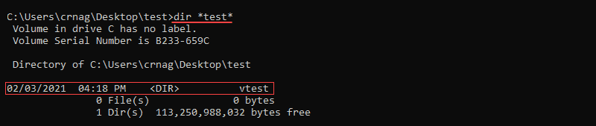

**Step 3: Activate the Environment**

Activate the virtual environment before installing Flask. The name of the activated environment shows up in the CLI after activation.

**Activate the Environment on Linux and MacOS**

Activate the virtual environment in Linux and MacOS with:

. <name of environment>/bin/activate



**Activate the Environment on Windows**

**For Windows, activate the virtual environment with:**

<name of environment>\Scripts\activate

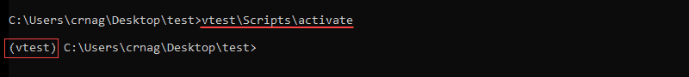

**Step 4: Install Flask**

**Install Flask within the activated environment using pip:**

pip install Flask

**Flask is installed automatically with all the dependencies.**

**Note:** **pip** is a Python package manager. To install **pip** follow one of our guides: [How to install pip on CentOS 7](https://phoenixnap.com/kb/how-to-install-pip-centos-7), [How to install pip on CentOS 8](https://phoenixnap.com/kb/how-to-install-pip-on-centos-8), [How to install pip on Debian](https://phoenixnap.com/kb/how-to-install-pip-on-debian-9), or [How to install pip on Ubuntu](https://phoenixnap.com/kb/how-to-install-pip-on-ubuntu).

**Step 5: Test the Development Environment**

1. Create a simple Flask application to test the newly created development environment.

2. Make a file in the Flask project folder called *hello.py*.

3. Edit the file using a text editor and add the following code to make an application that prints "*Hello world!*":

from flask import Flask

app = Flask(__name__)

@app.route('/')

def hello_world():

return 'Hello world!'

**Note:** Pick any name for the project except *flask.py*. The Flask library is in a *flask.py* file.

4. Save the file and close.

5. Using the console, navigate to the project folder using the **cd** command.

6. Set the *FLASK_APP* environment variable.

setx FLASK_APP "hello.py"

**Note:** Windows users must restart the console to set the environment variable. Learn more about setting environment variables by reading one of our guides: [**How to set environmet variables in Linux**](https://phoenixnap.com/kb/linux-set-environment-variable)**,**[**How to set environment variables in MacOS**](https://phoenixnap.com/kb/set-environment-variable-mac)**,**[**How to set environment variables in Windows**](https://phoenixnap.com/kb/windows-set-environment-variable)**.**

7. Run the Flask application with:

flask run

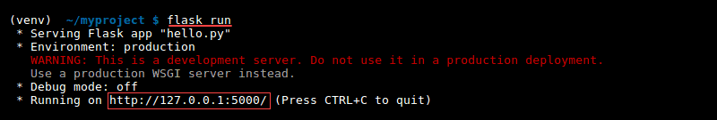

The output prints out a confirmation message and the address.

8. Copy and paste the address into the browser to see the project running:

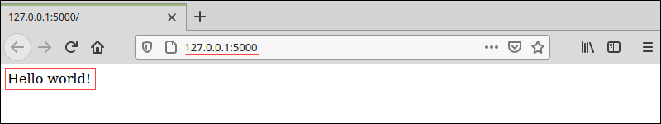

To implement microservices in Python using Flask, you'll create separate Flask applications for each microservice. Here's how you can structure and document each microservice:

1. Product Service:

Functionality: Manages product information, such as CRUD operations for products, categories, and inventory.

Endpoints:

/products: GET (get all products), POST (add new product)

/products/<id>: GET (get product by id), PUT (update product), DELETE (delete product)

/categories: GET (get all categories)

Dependencies: Flask framework, possibly Flask-RESTful for building RESTful APIs, and any additional libraries for database interaction (e.g., SQLAlchemy for ORM).

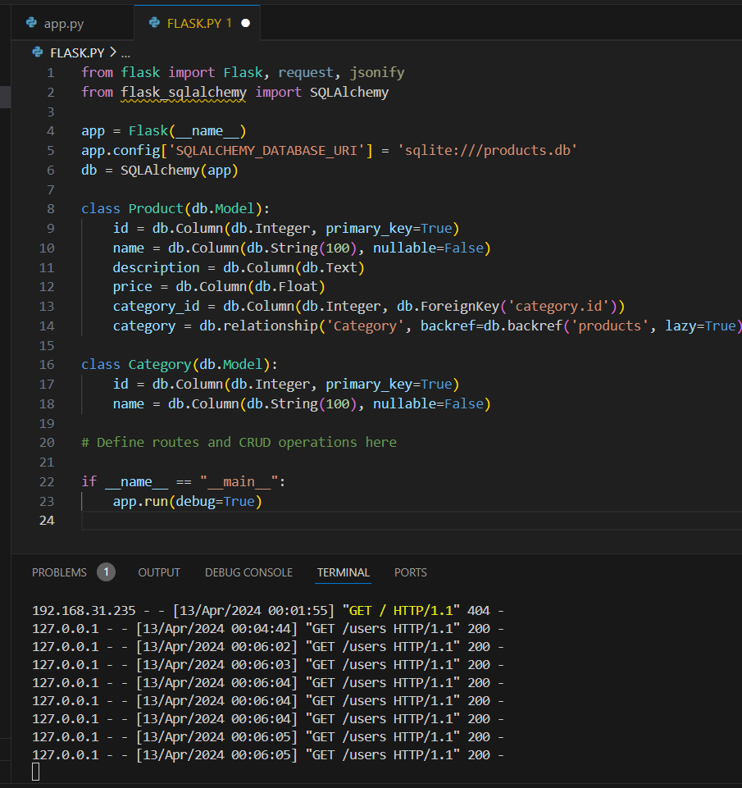

2. User Service:

Functionality: Handles user authentication, registration, and profile management.

Endpoints:

/register: POST (register new user)

/login: POST (user login)

/profile: GET (get user profile), PUT (update user profile)

Dependencies: Flask framework, possibly Flask-JWT for authentication, and any libraries for user management (e.g., Flask-SQLAlchemy for ORM).

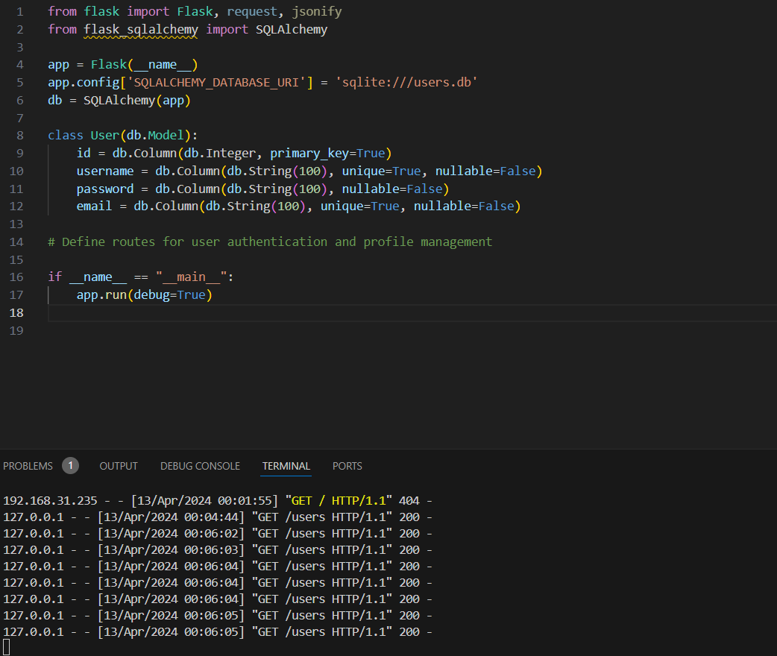

# Define routes for user authentication and profile management

3. Order Service:

Functionality: Manages order creation, listing, and status updates.

Endpoints:

/orders: GET (get all orders), POST (create new order)

/orders/<id>: GET (get order by id), PUT (update order status), DELETE (delete order)

Dependencies: Flask framework, possibly Flask-SQLAlchemy for ORM, and any additional libraries for order management.

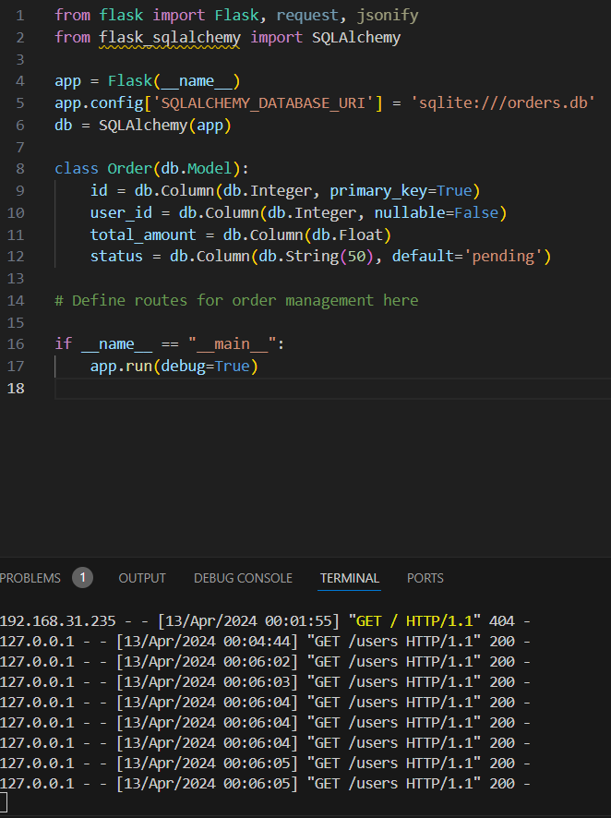

# Define routes for order management here

4. Payment Service:

Functionality: Handles payment processing and integration with payment gateways.

Endpoints:

/payment: POST (process payment)

Dependencies: Flask framework, any libraries for payment processing (e.g., Stripe SDK), and possibly Flask-SQLAlchemy for storing payment records.

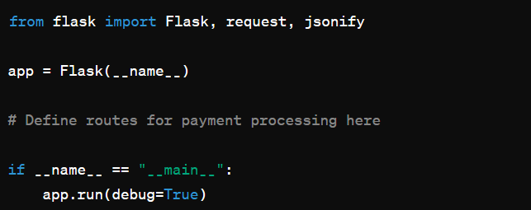

**Step 1: Downloading Docker**

The first place to start is the [official Docker website](https://www.docker.com/get-started/) from where we can download Docker Desktop.

Please note that Docker Desktop is intended only for Windows 10/11 and not for Windows Server.

So let’s open the downloaded installer and begin the installation.

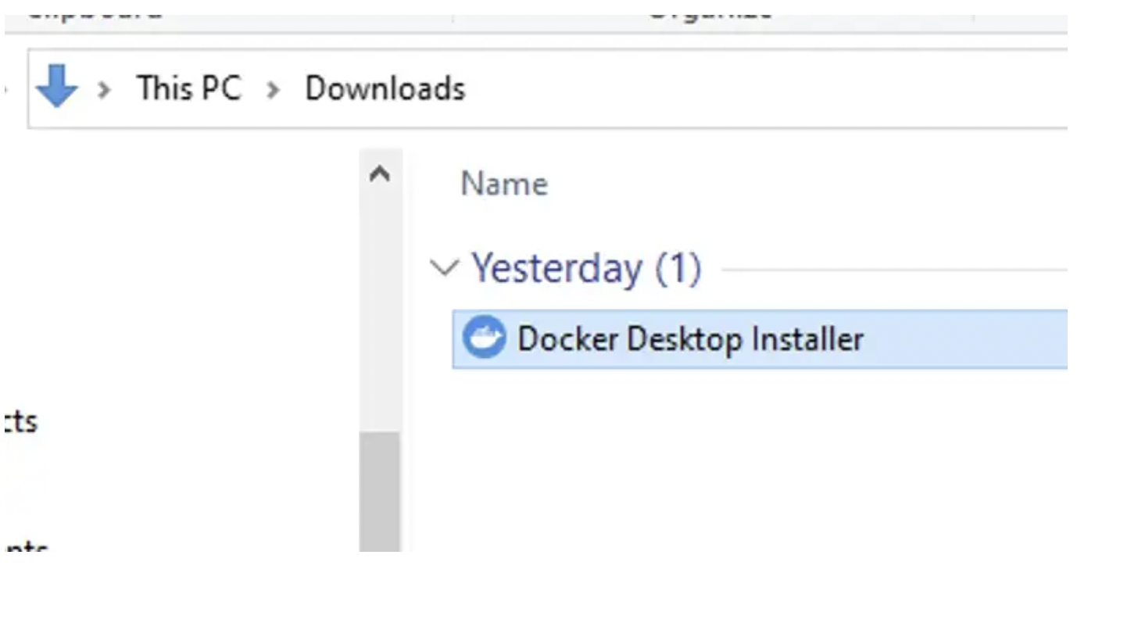

**Step 2: Configuration**

To run Linux on Windows, Docker requires a virtualization engine. Docker recommends using WSL 2

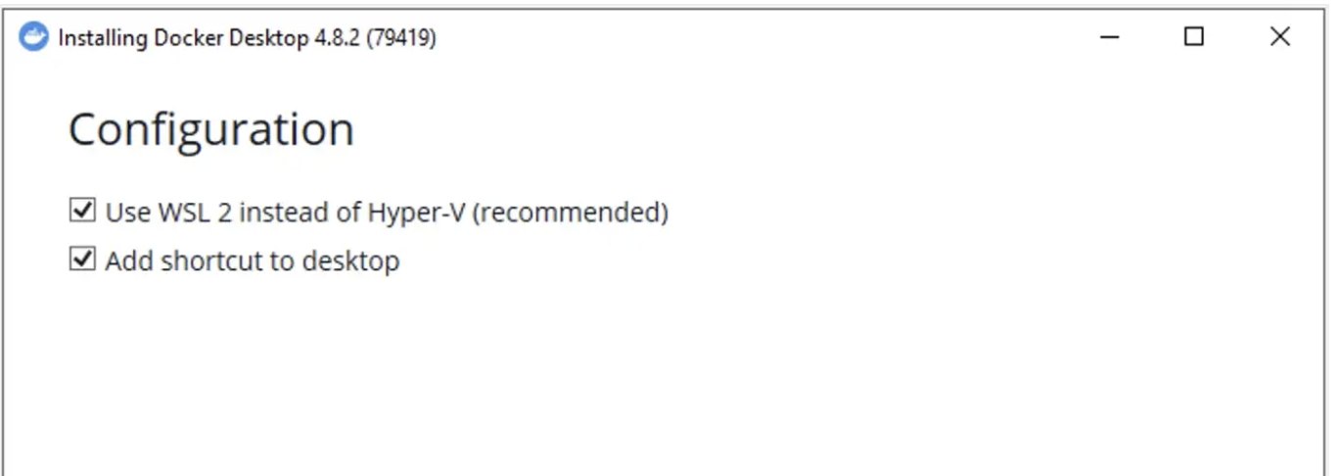

**Step 3: Running the instalation**

Click Ok, and wait a bit…

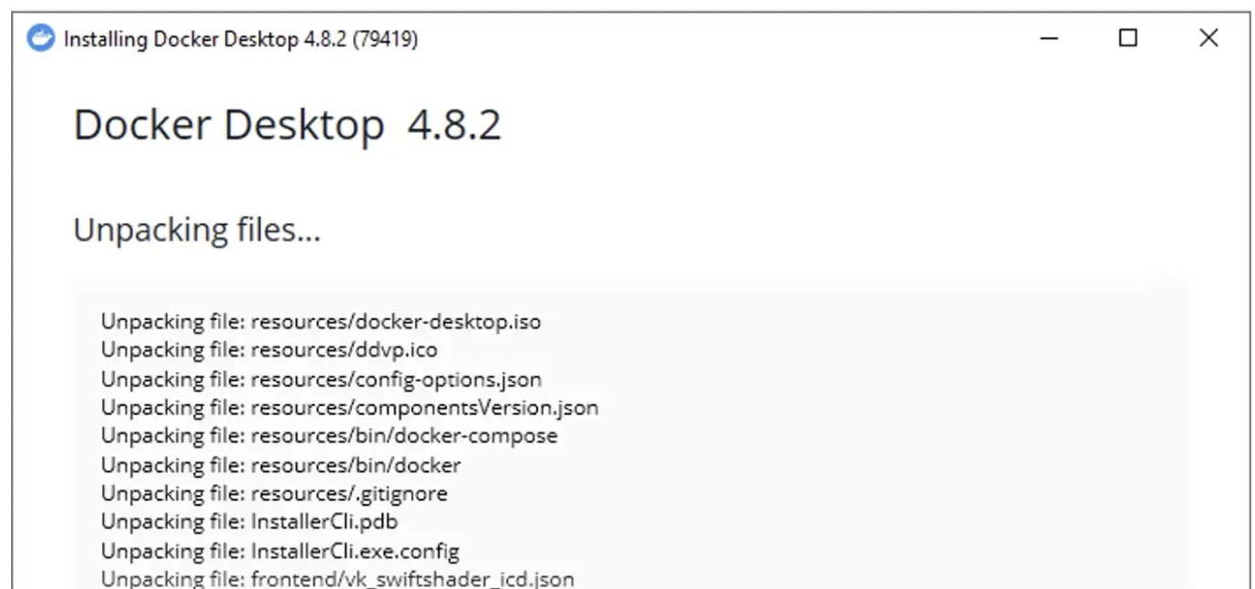

**Step 4: Restart**

For Docker to be able to properly register with Windows, a restart is required at this point.

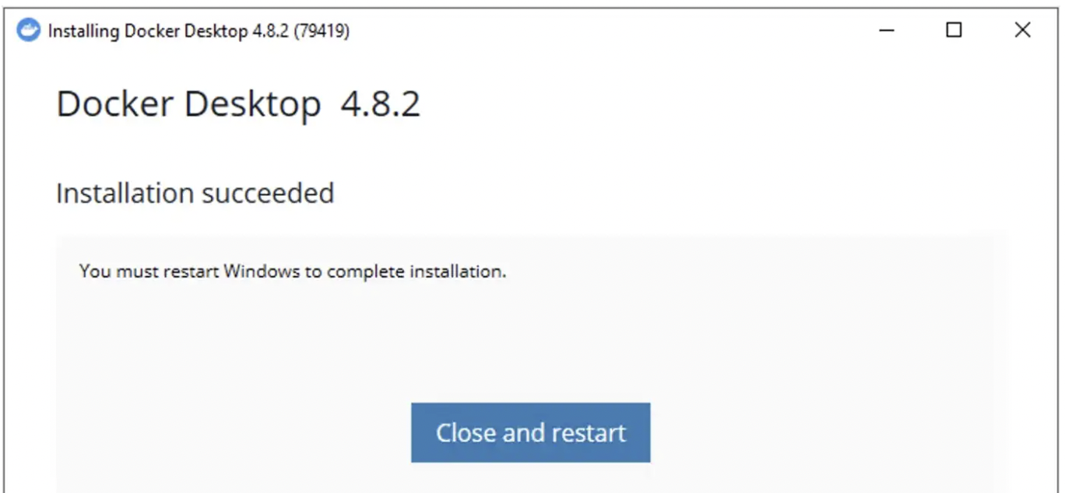

**Step 5: License agreement**

After the restart, Docker will start automatically and you should see the window below:

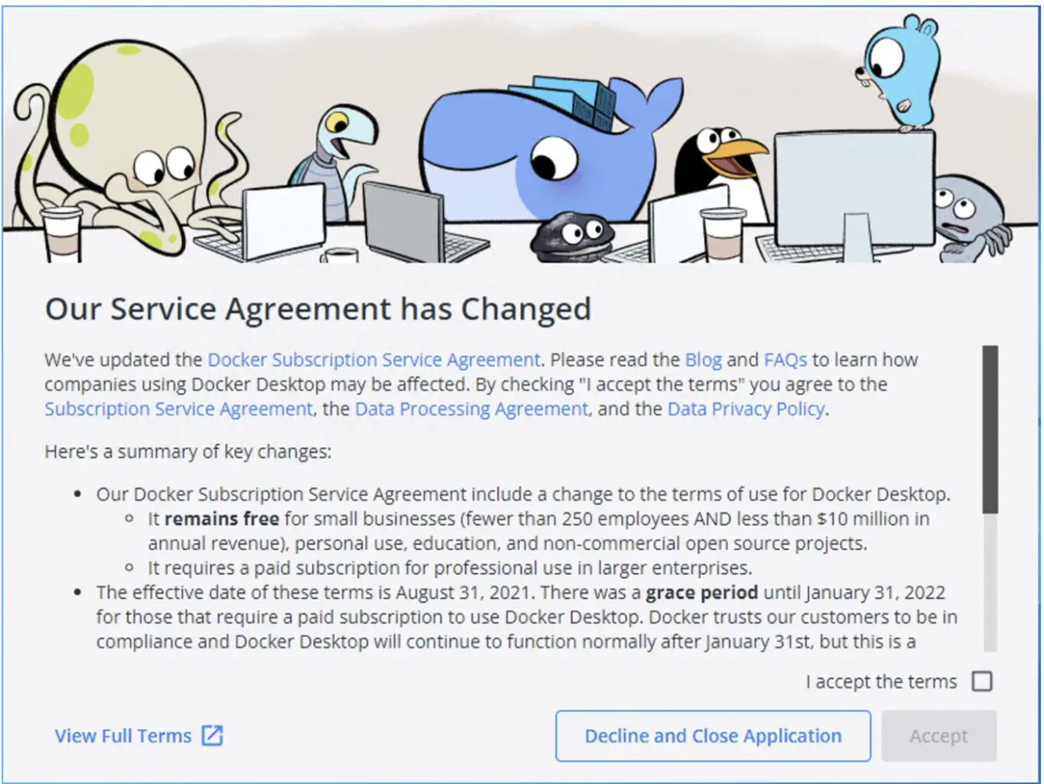

Essentially, if you are a small business or use Docker for personal use, Docker contains to remain free. However, **if you are in a large organization, please get in touch with your IT department to clarify the license agreement.**

**Step 6: WSL 2 installation**

After you accept the license terms, the Docker Desktop window will open. However, we are not done yet. Since we have selected WSL 2 as our virtualization engine, we also need to install it. **Don’t click Restart just yet!**

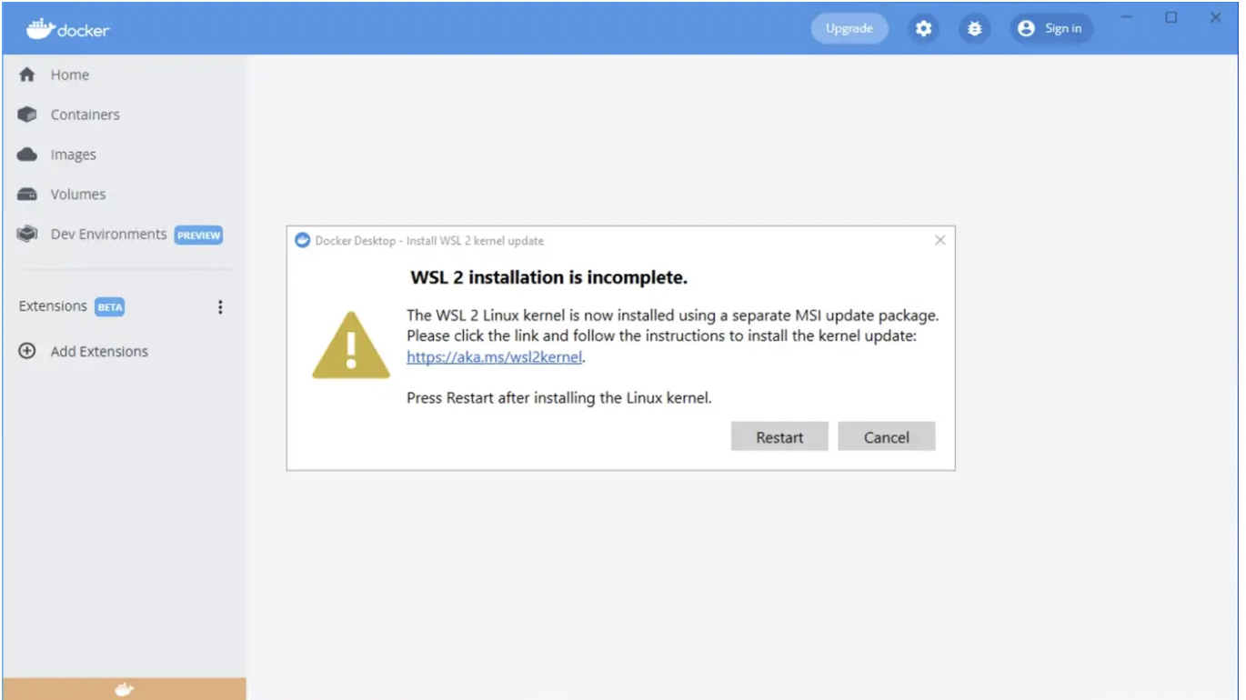

Follow the link in the dialog window and download WSL 2.

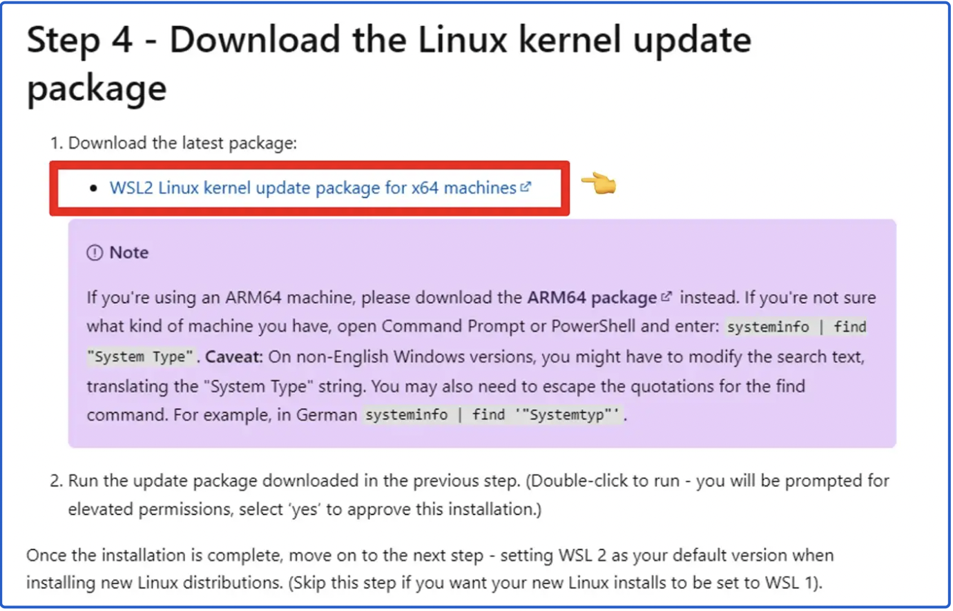

**Open the installer.**

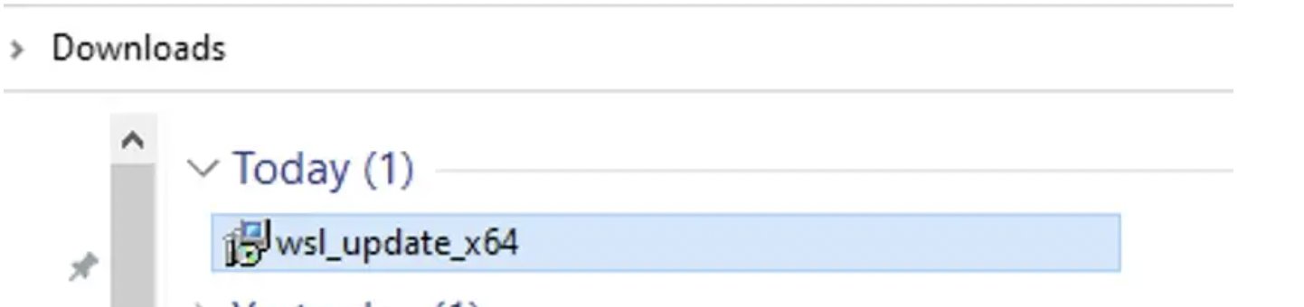

Click on *Next* to begin installing the Windows Subsystem for Linux (WSL).

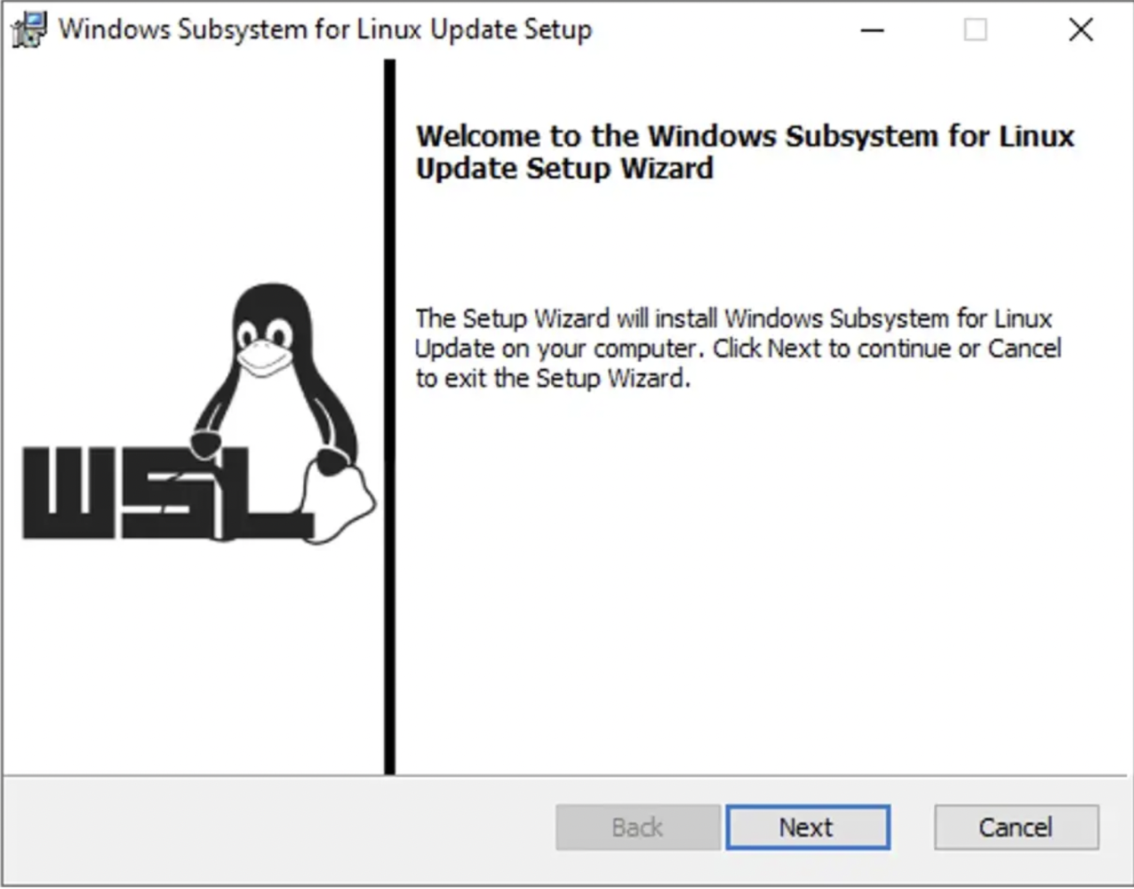

After a few seconds, the installation should complete. So, you may click on Finish.

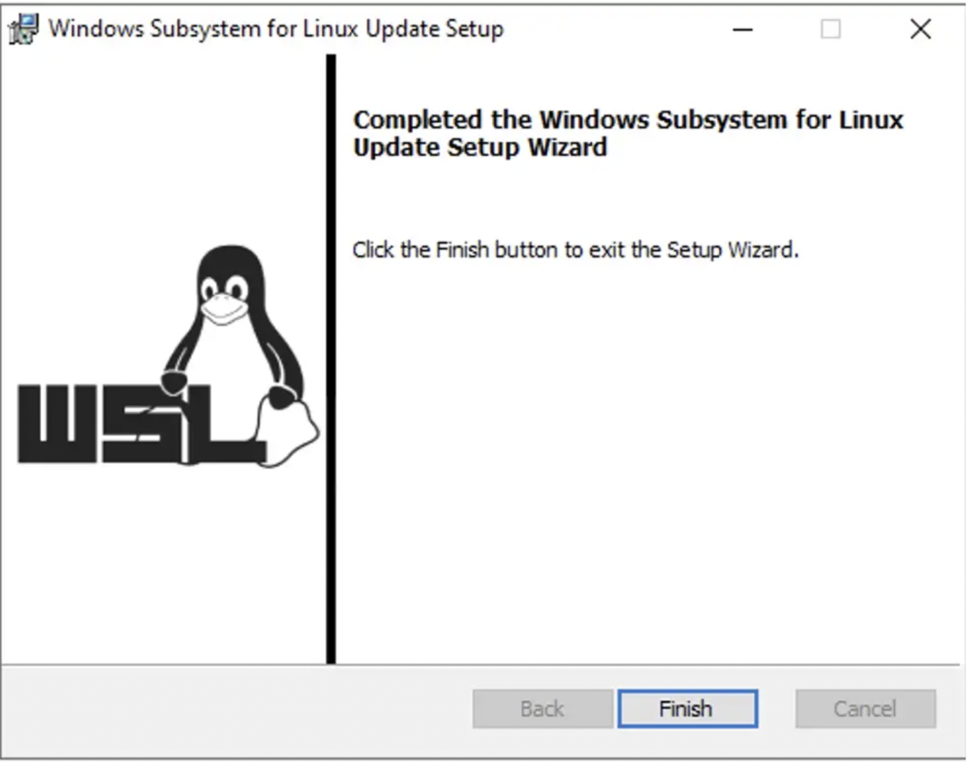

If you still have the Docker Desktop dialog window in the background, click on Restart. Otherwise, just restart your computer as you normally do.

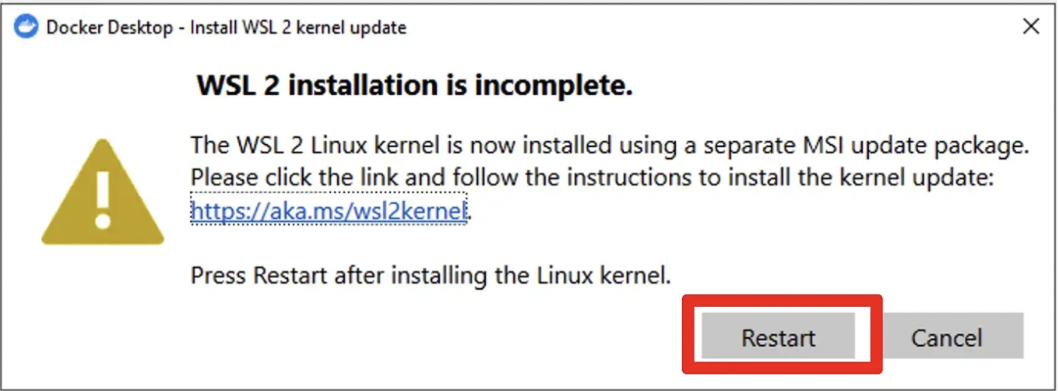

**Step 7 — Starting Docker Desktop**

If Docker Desktop did not start on its own, simply open it from the shortcut on your Desktop.

If you wish, you can do the initial orientation by clicking Start.

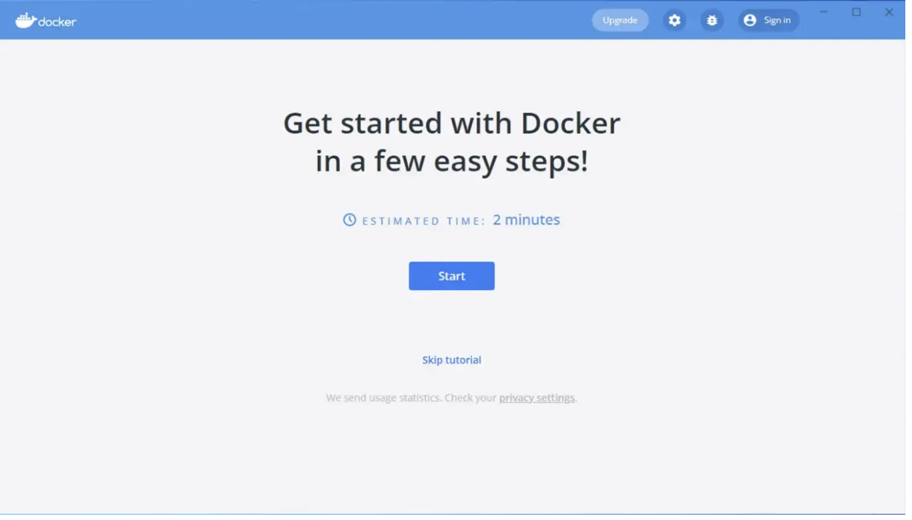

After this, your Docker Desktop screen should look like this.

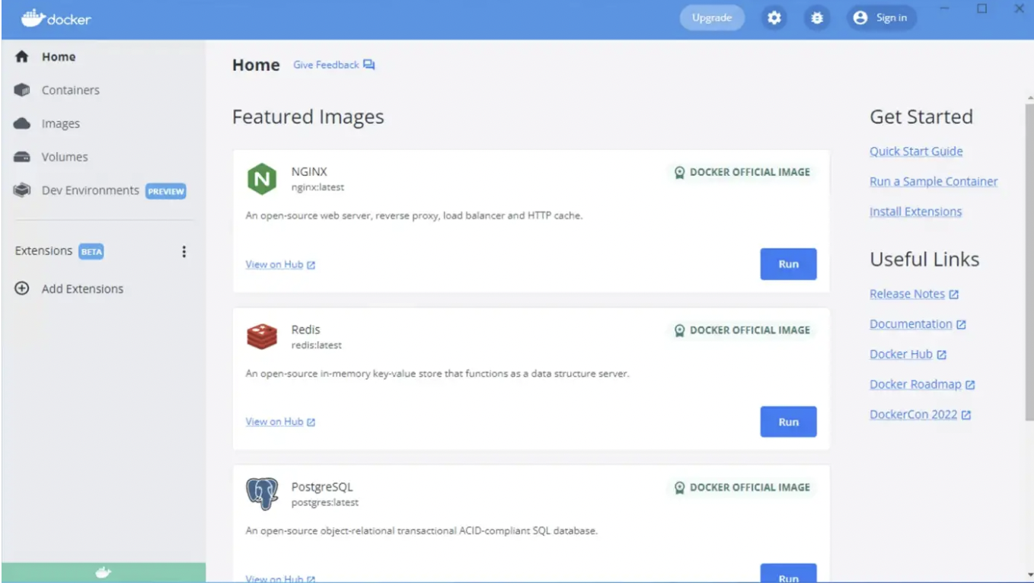

**Step 8— Testing Docker**

Open your favorite command line tool and type in the following command:

docker run hello-world

This will download the hello-world Docker image and run it. This is just a quick test to ensure everything is working fine.

**Step 9 — Automatically start Docker [Optional]**

**This step is dependently optional**, but if you are working a lot with Docker, you may want to configure Docker Desktop to start automatically once you start Windows.

You can enable this from settings, as shown in the screenshot below.

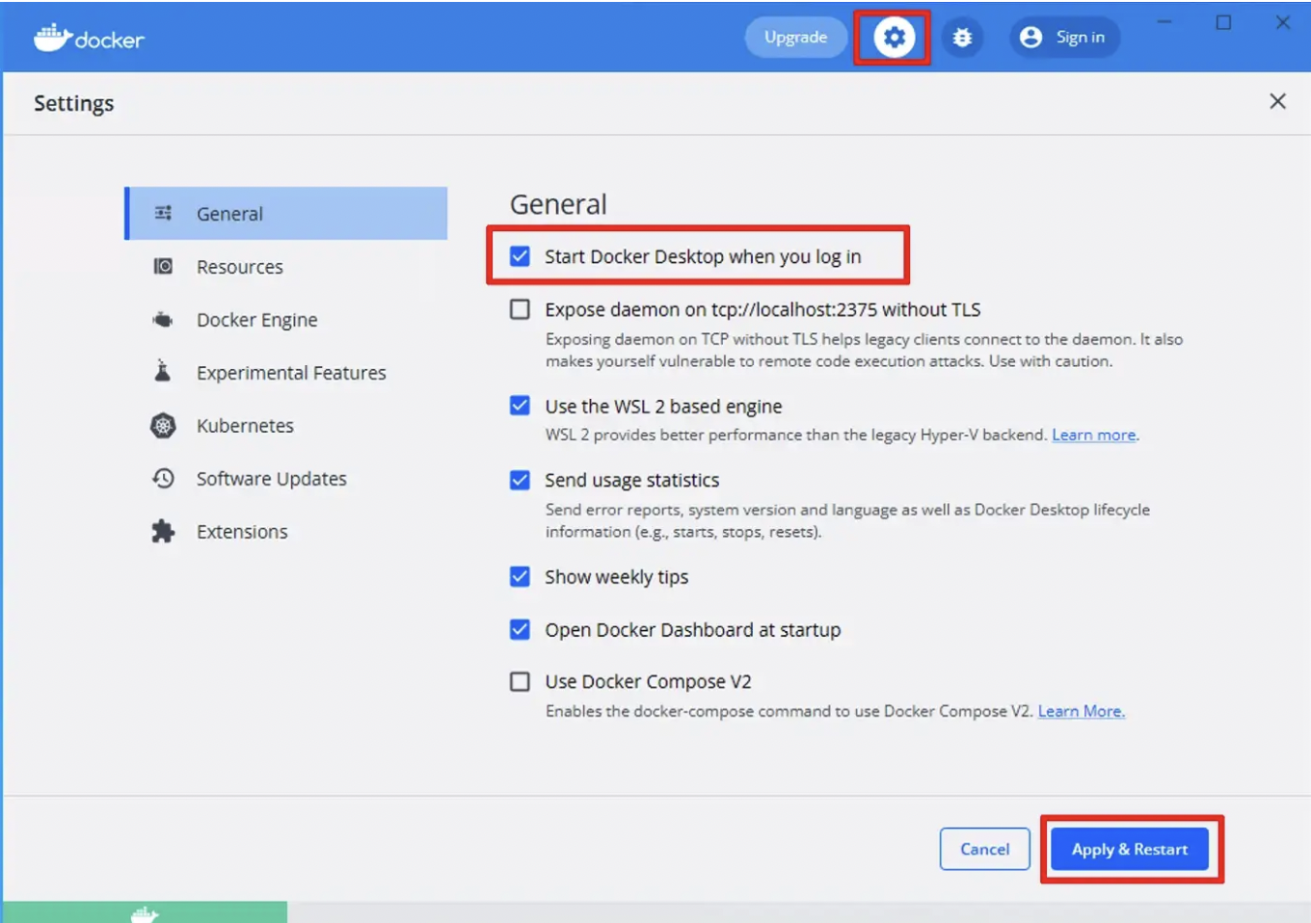

### Step 3: Install Kubernetes

Docker comes with a GUI tool that allows users to configure Docker settings and install and enable Kubernetes.

**Note:** Take a look at the [best Kubernetes practices](https://phoenixnap.com/kb/kubernetes-best-practices) that will help you create stable and efficient clusters.

There are **several methods for installing Kubernetes**. This article will cover installing Kubernetes via the Docker settings, Minikube, and Kind. Depending on your machine's specifications, choose the method that suits your system:

* **Minikube**requires at least 2GB of RAM and 2 CPUs.
* **Kind**requires 8GB of RAM to deliver good performance.
* Installing Kubernetes via **Docker settings** takes up to 8 GB of RAM.

Before installing Kubernetes, install [kubectl](https://phoenixnap.com/kb/kubectl-commands-cheat-sheet), the Kubernetes CLI tool. This utility lets you run commands against Kubernetes clusters.

Follow these steps to install kubectl:

1. Navigate to the official [kubectl download page](https://kubernetes.io/docs/tasks/tools/install-kubectl-windows/) and locate the *Install kubectl binary* section:

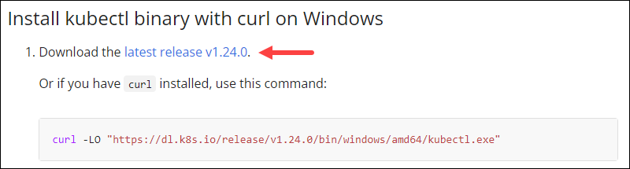

2. Click the download link for the latest release. At the time of writing this article, the latest release was 1.24.0. Save the file to a directory such as *C:\kubectl*.

3. Press the **Windows** button and search for *Environment variables*. Select **Edit the system environment variables**.

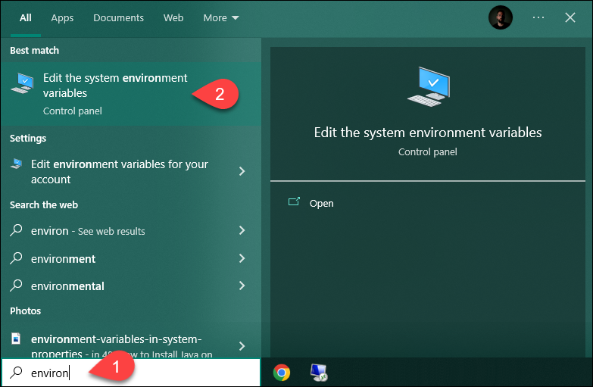

4. In the System Properties window, click **Environment Variables…**

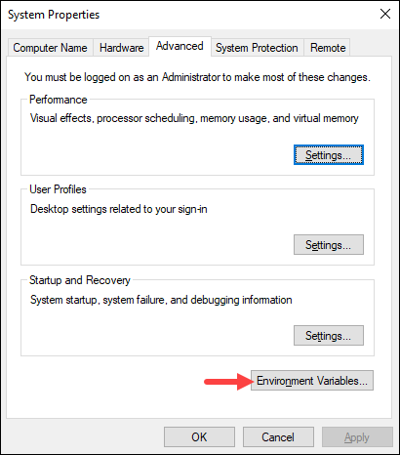

5. Under the *System Variables* section, click the **Path** environment variable and select **Edit** to add the kubectl system variable:

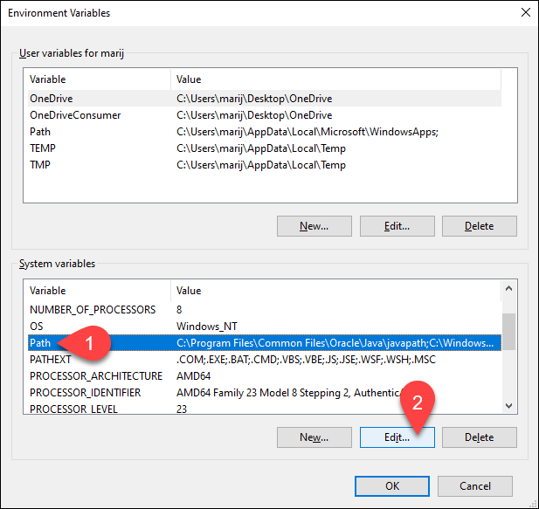

6. Click **New** and add the path to the downloaded kubectl [binary file](https://phoenixnap.com/glossary/binary-file). Select **OK** in all windows to confirm the changes.

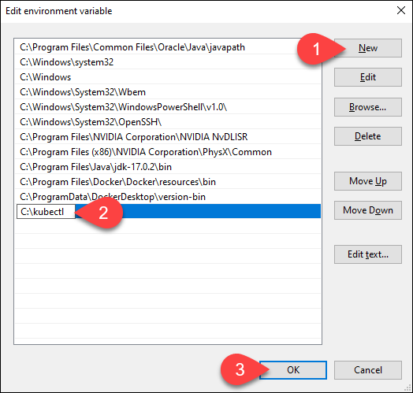

7. Check if everything is set up correctly by running **kubectl** in Windows PowerShell:

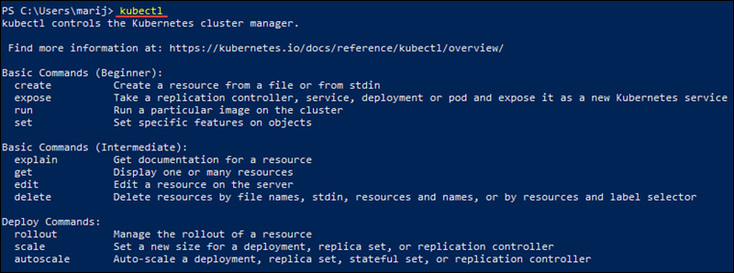

#### Via Docker GUI

The easiest way to install Kubernetes is by enabling it in Docker settings. Follow the steps below to do so:

1. In the system tray, right-click the **Docker icon**. Select **Settings** from the menu.

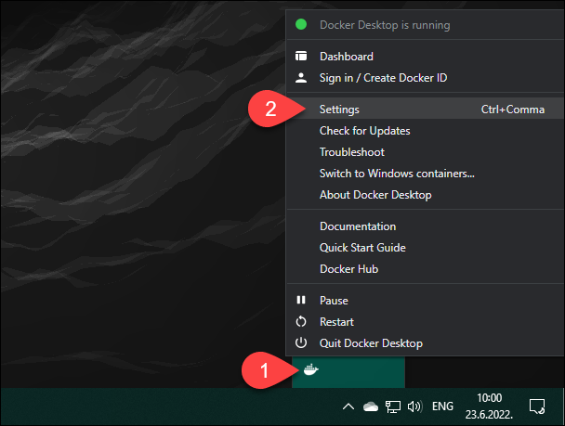

**Important:** If the Docker icon is missing from the system tray, reboot your system. If the problem persists, check the [official troubleshooting guide](https://docs.docker.com/docker-for-windows/troubleshoot/).

2. In Docker settings, select the *Kubernetes* tab. Check the **Enable Kubernetes** box and click **Apply & Restart**.

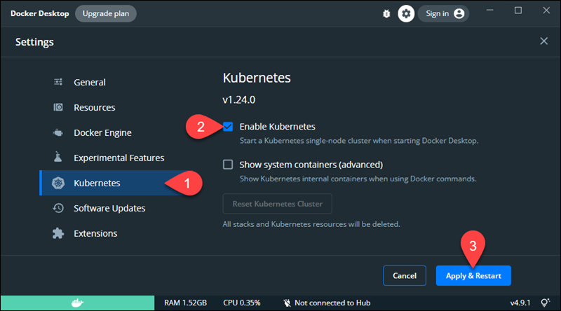

3. When prompted, click **Install** to proceed.

4. The tool downloads the necessary cluster components and creates another VM in the background. When the installation finishes, both the Docker and Kubernetes icons are green, which means they are up and running:

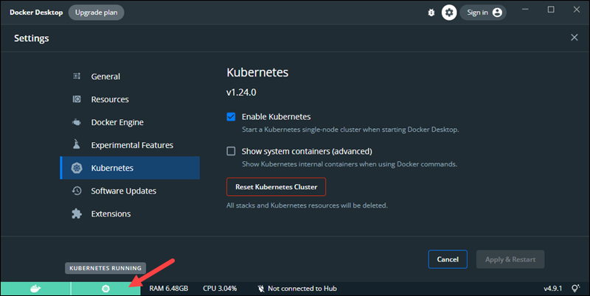

#### Via Minikube

Minikube is an open-source tool for running Kubernetes. It works with Linux, Mac, and Windows by running a single-node cluster inside a virtual machine on the local machine.

Follow the steps below to install Kubernetes via Minikube:

**Install Using winget:**

1. If you are using [winget](https://phoenixnap.com/kb/install-winget), the Windows package manager, install Minikube by running:

winget install minikube

The output shows when the installation finishes.

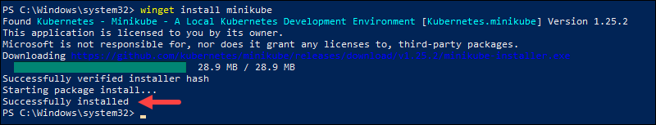

**Install Using the Installer Wizard**

1. [Download the latest Minikube release](https://storage.googleapis.com/minikube/releases/latest/minikube-installer.exe) and start the executable installer.

2. On the Welcome screen, click **Next** to proceed.

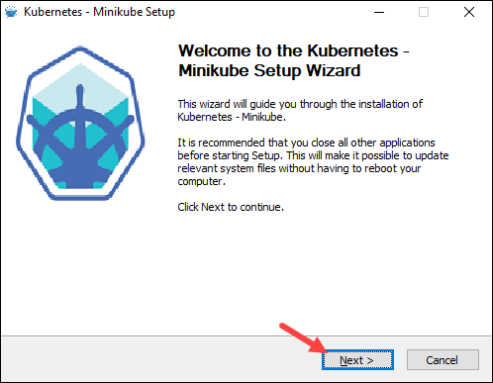

3. Read the License Agreement and click **I Agree** to proceed to the next step.

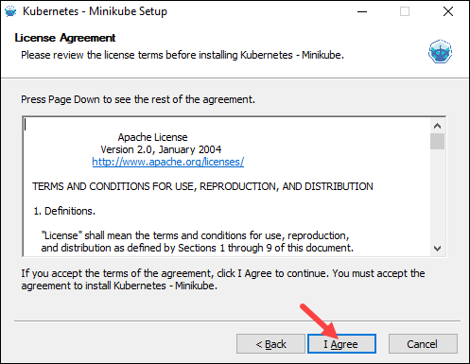

4. Choose a custom install location for Minikube or leave the default one and click **Install**.

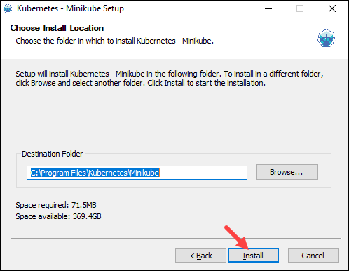

5. After the installation completes, click **Next** and **Finish** to exit the installer.

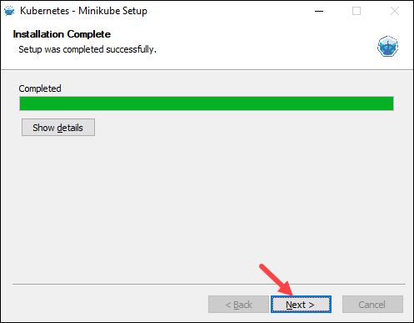

After installation, start the Minikube cluster by running the following command:

minikube start

The output shows **Done!**once the installation finishes.

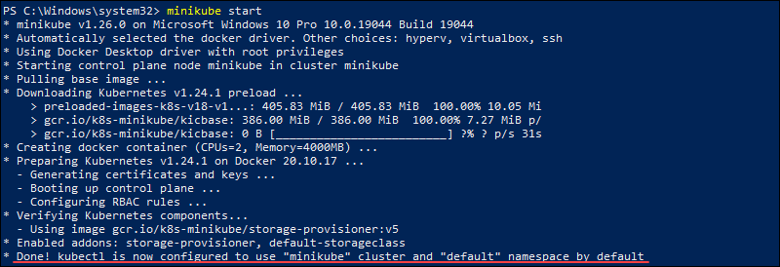

#### Via Kind (Kubernetes in Docker)

Kind is short for Kubernetes in Docker, which means having Docker installed on your machine is a prerequisite for Kind. [Kind](https://phoenixnap.com/kb/kubernetes-kind) works by running Kubernetes as a group of Docker containers without creating a VM. Thus, Kind has a faster startup time compared to Minikube.

Follow the steps below to install Kind:

1. Using a web browser, navigate to the [official Kind releases page](https://github.com/kubernetes-sigs/kind/releases).

2. Scroll down to the *Assets* section and click the download link for the Windows version.

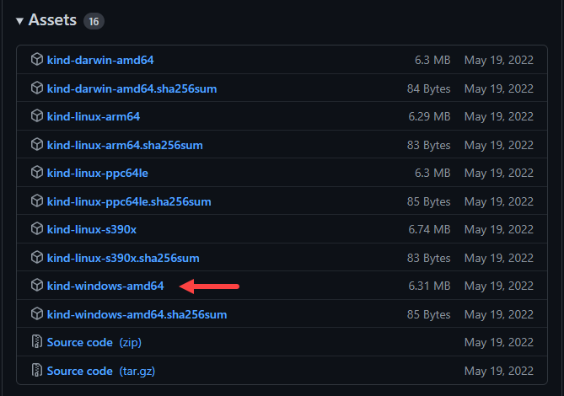

3. Rename the downloaded file to *kind.exe*.

4. Move the downloaded file to a directory such as *C:\kind*, and add the path to the system environment variables. Follow the same steps listed above for adding the *kubectl* environment variable path.

4. Create a cluster with Kind by running the following command in Windows PowerShell:

kind create cluster

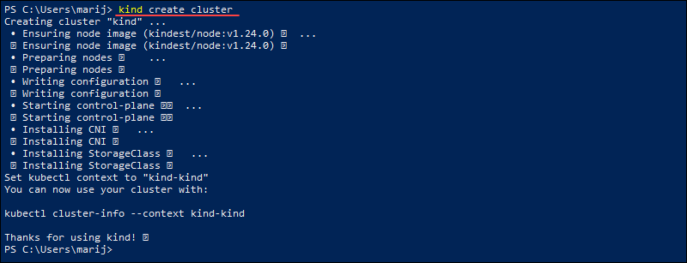

### Step 4: Install Kubernetes Dashboard

The Kubernetes Dashboard is the official web-based UI for managing Kubernetes resources, and it is an alternative to the kubectl CLI tool. However, it needs to be set up manually as it doesn't automatically deploy.

Use the Dashboard to deploy containerized applications to a Kubernetes cluster or manage the cluster resources. You can view a summary of applications running on the cluster and use the options to create or modify individual Kubernetes resources.

Follow the steps below to **install the Kubernetes Dashboard**:

1. Open Windows PowerShell as an administrator and run the following command to deploy the Kubernetes Dashboard:

kubectl apply -f https://raw.githubusercontent.com/kubernetes/dashboard/v2.6.0/aio/deploy/recommended.yaml

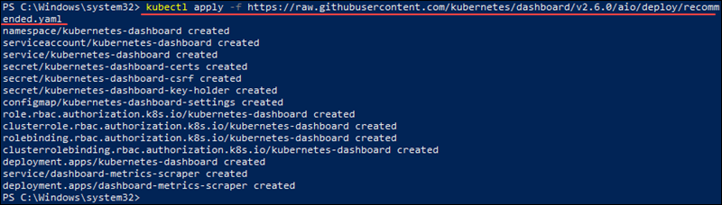

2. Create a secure channel for accessing the Dashboard by running:

kubectl proxy



3. Access the Dashboard Login page at **http://localhost:8001/api/v1/namespaces/kubernetes-dashboard/services/https:kubernetes-dashboard:/proxy/**

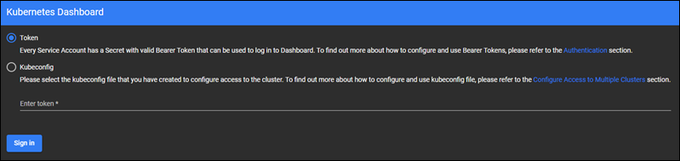

**Note:** To be able to log in, you need to create a user and have a token. Follow the official guide for [creating a sample user and bearer token](https://github.com/kubernetes/dashboard/blob/master/docs/user/access-control/creating-sample-user.md).

4. After logging in, the Dashboard shows an overview similar to the following image:

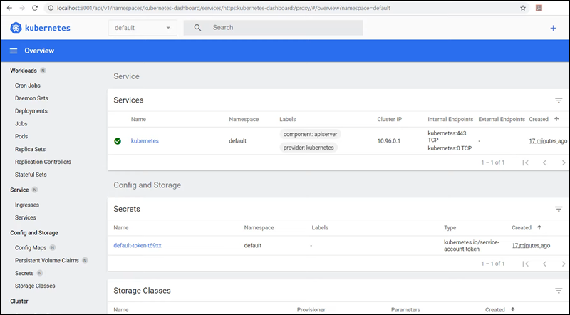

## How to Uninstall Kubernetes on Windows

Depending on how you installed Kubernetes, there are several methods for uninstalling:

**Uninstall From Docker Settings**

If you enabled Kubernetes in Docker settings, uncheck the **Enable Kubernetes** box and click **Apply and Reset**. The Kubernetes VM is automatically removed.

**Uninstall Minikube**

If you installed Kubernetes via Minikube, run the following commands to stop and delete the VM:

minikube stop

minikube delete

After that, delete the *.minikube* and *.kube* directories from the system.

**Uninstall Kind**

To uninstall Kind, delete any cluster with the following syntax:

kind delete cluster --name [name]

If you didn't specify a cluster name during creation, run:

kind delete cluster

After deleting created clusters, remove the directory you used to set up Kind.

o solve the issue outlined above, I crafted a simple shot-scraper macro to remove elements from the page:

- type: function

name: removeElementBySelector

javascript: |

function (selector) {

const elementToDelete = document.querySelector(selector);

if (elementToDelete) {

elementToDelete.parentNode.removeChild(elementToDelete);

}

}

This macro was used in the following shot-scraper script to hide the Mesh Manager section in the sidebar:

- output: ../../app/assets/images/docs/konnect/konnect-control-plane-dashboard.png

url: https://cloud.konghq.com/us/gateway-manager/

wait: 4000

width: 1920

height: 800

javascript: |

removeElementBySelector('a.sidebar-item-link[href="/us/mesh-manager/"]');

Without shot-scraper, we would have had to edit the page manually using developer tools each time the page loaded:

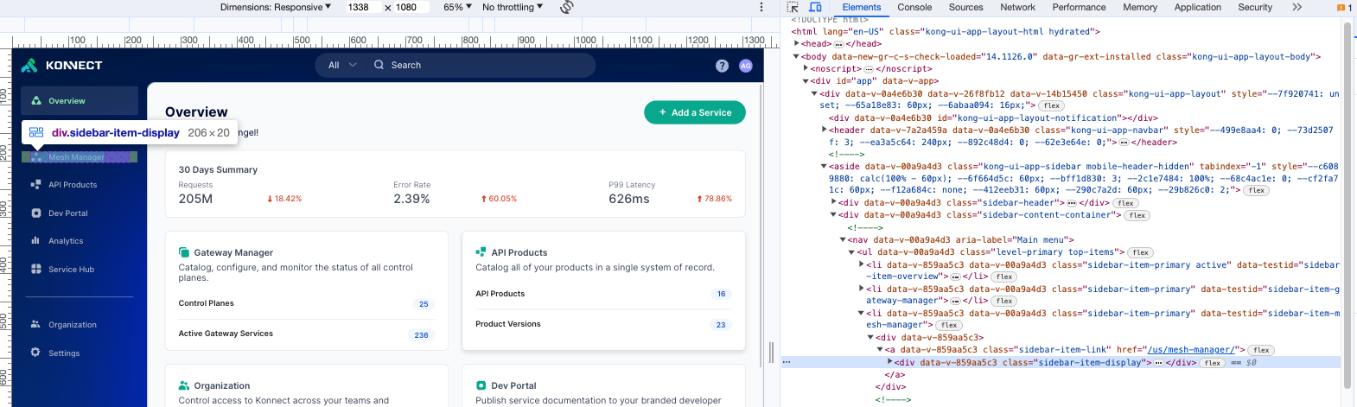

**What else can shot-scraper do?**

We use shot-scraper for a variety of different tasks:

1. Take a standard screenshot of a dashboard:

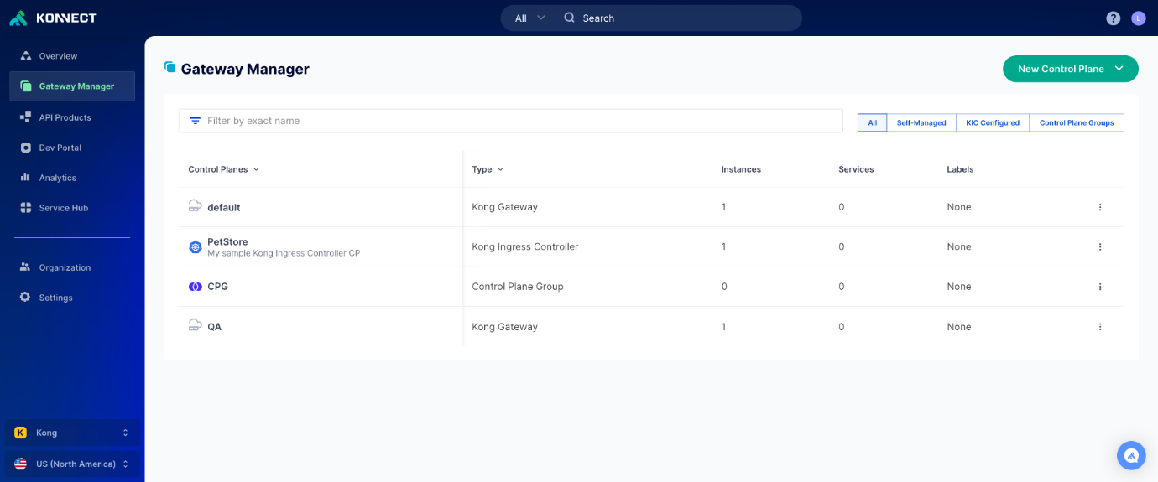

- output: ../../app/assets/images/docs/konnect/konnect-control-plane-dashboard.png

url: https://cloud.konghq.com/us/gateway-manager/

wait: 4000

width: 1920

height: 800

2. Update the page with random values (in this case the number of requests):

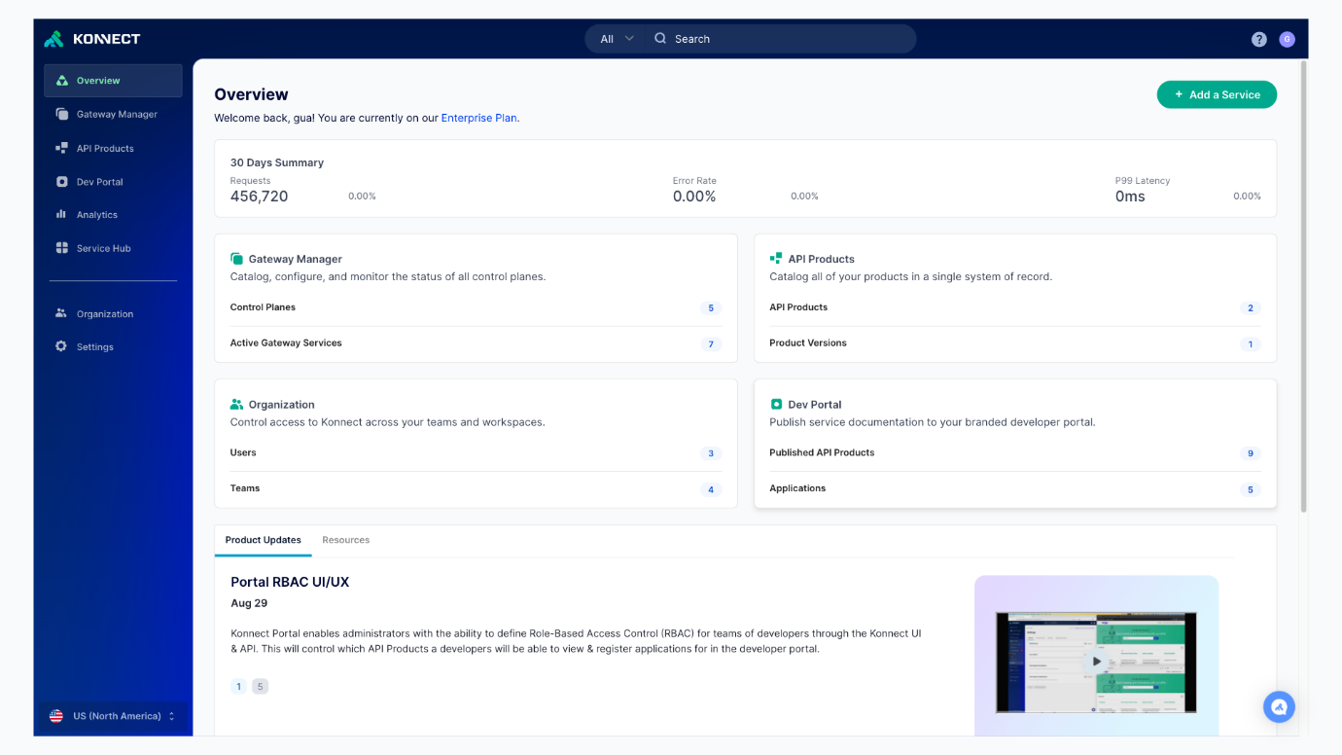

- output: ../../app/_assets/images/docs/konnect/konnect-dashboard.png

url: https://cloud.konghq.com/us/overview/

wait: 4000

width: 1920

height: 1080

javascript: |

async () => {

updateDivWithRandomNumberInRange('div[data-v-ee980c4c][style="font-size: 22px;"]', 30000, 600000);

}

3. Add annotations to specific elements on a page that you can reference in written documentation:

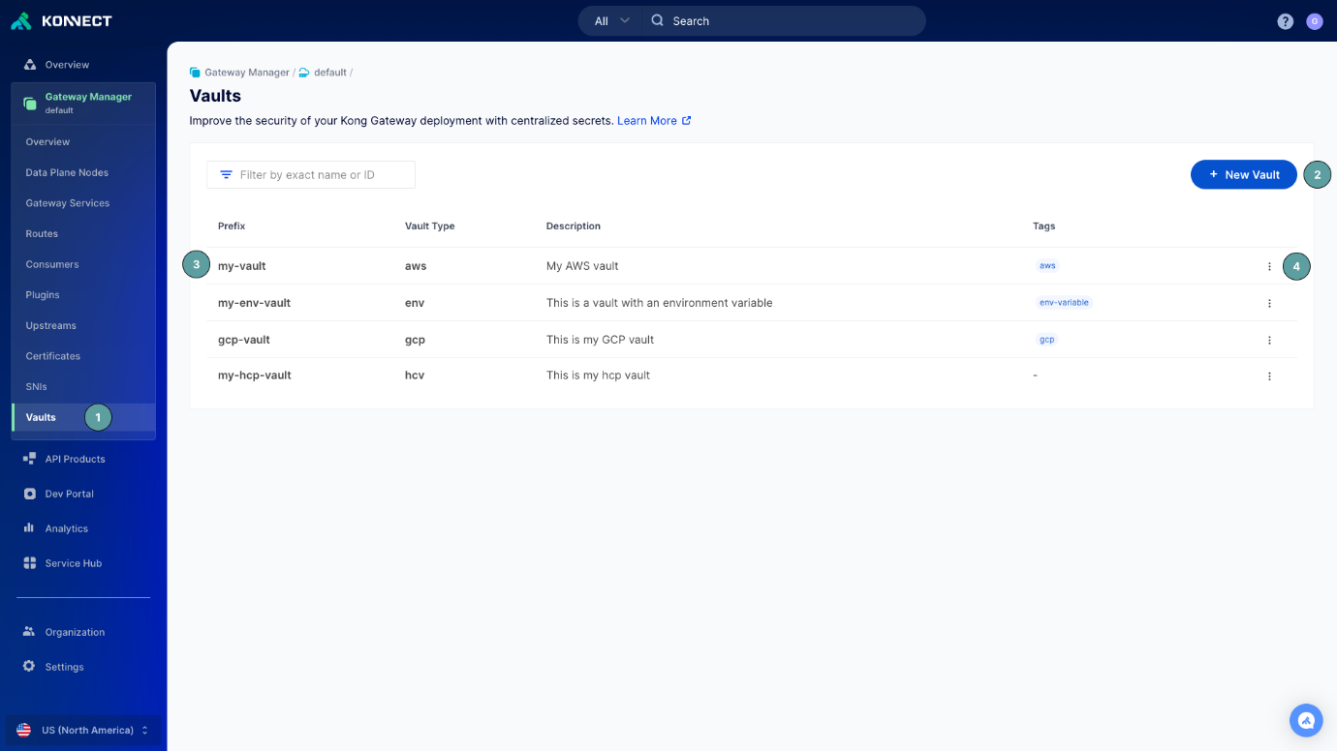

- output: ../../app/_assets/images/docs/konnect/konnect-vaults.png

url: https://cloud.konghq.com/us/runtime-manager/988f1fa1-fd93-4ef7-a1f5-c481bd86e945/vaults

wait: 4000

width: 1920

height: 1080

javascript: |

async () => {

const sidebarItem = document.querySelector("#subnav-gateway-manager > li.sidebar-item-secondary.active > a");

const prefixItem = getTestId('prefix');

const addItem = getTestId('toolbar-add-vault');

const menuItem = getTestId('overflow-actions-button');

annotateNumber(sidebarItem, { number: 1, position: { left: "100px" } });

annotateNumber(addItem, { number: 2, position: { right: "-50px" } });

annotateNumber(prefixItem, { number: 3, position: { left: "-35px", top: "4px" } });

annotateNumber(menuItem, { number: 4, position: { right: "-35px" } });

}

4. Interact with the page like a user. Here, we configure a graph in our Analytics dashboard builder:

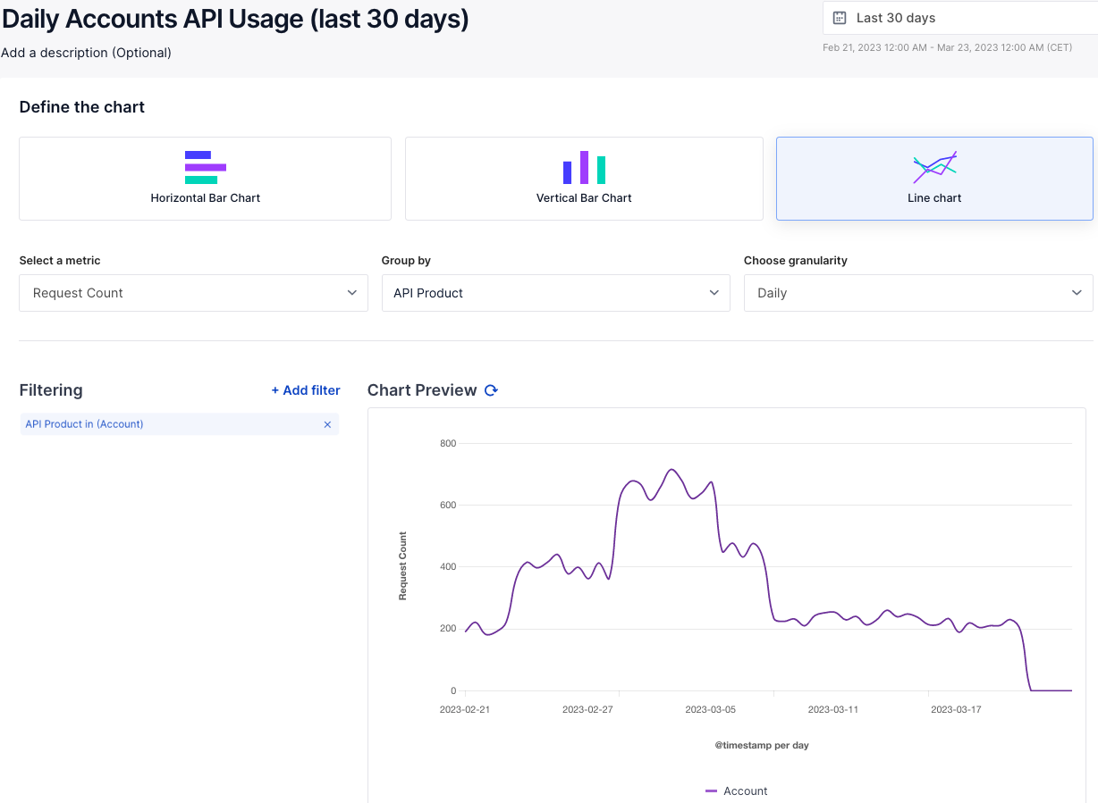

- output: ../../app/_assets/images/docs/konnect/custom-reports/api-usage-by-application.png

url: https://cloud.konghq.com/us/analytics/reports/create

wait: 4000

width: 1920

height: 1080

javascript: |

async () => {

// Configure the report we want to see

const form = document.querySelector(".report-form form");

// Set the report title

form.querySelector("h1").textContent = "API Usage by Application (last 30 days)";

await sleep(500);

// Select "Vertical Bar Chart" and wait for the UI to update

await activateByTestId('chart-type-VerticalBar');

// And the time duration

await activateByTestId('k-datetime-picker-display');

await activateByTestId('select-timeframe-30d');

await activateByTestId('k-datetime-picker-submit');

// Group by Service

form.querySelector(".select-group-by .k-select-input").click();

await sleep(200);

await activateByTestId('k-select-item-Service');

// Then by Application

form.querySelector(".select-then-by .k-select-input").click();

await sleep(200);

await activateByTestId('k-select-item-Application');

// Wait for the chart to render

await sleep(1000);

// The "selector" option didn't work well for some reason. This takes a nice screenshot without sidebar/header

cleanupPage();

}

Using shot-scraper, our docs team can write scripts once and have screenshots that are up-to-date, accurate, and reproducible by anyone on the team.